A STUDY ON

THE…………………………………………

…CREDIT CARD FRAUD DETECTION…

PROJECT REPORT

SUBMITTED BY:

HARSH BANSAL

BACHELOR OF TECHNOLOGY

IN

INFORMATION TECHNOLOGY

NORTHERN INDIA ENGINEERING COLLEGE

KASHMERE GATE, DELHI

AUGUST 2019

**ACKNOWLEDGEMENT**

The dataset has been collected and analyzed during a research collaboration of Worldline and the Machine Learning Group ([http://mlg.ulb.ac.be](http://mlg.ulb.ac.be/)) of ULB (Université Libre de Bruxelles) on big data mining and fraud detection. More details on current and past projects on related topics are available on <https://www.researchgate.net/project/Fraud-detection-5> and the page of the [DefeatFraud](https://mlg.ulb.ac.be/wordpress/portfolio_page/defeatfraud-assessment-and-validation-of-deep-feature-engineering-and-learning-solutions-for-fraud-detection/) project

Please cite the following works:

Andrea Dal Pozzolo, Olivier Caelen, Reid A. Johnson and Gianluca Bontempi. [Calibrating Probability with Undersampling for Unbalanced Classification.](https://www.researchgate.net/publication/283349138_Calibrating_Probability_with_Undersampling_for_Unbalanced_Classification) In Symposium on Computational Intelligence and Data Mining (CIDM), IEEE, 2015

Dal Pozzolo, Andrea; Caelen, Olivier; Le Borgne, Yann-Ael; Waterschoot, Serge; Bontempi, Gianluca. [Learned lessons in credit card fraud detection from a practitioner perspective](https://www.researchgate.net/publication/260837261_Learned_lessons_in_credit_card_fraud_detection_from_a_practitioner_perspective), Expert systems with applications,41,10,4915-4928,2014, Pergamon

Dal Pozzolo, Andrea; Boracchi, Giacomo; Caelen, Olivier; Alippi, Cesare; Bontempi, Gianluca. [Credit card fraud detection: a realistic modeling and a novel learning strategy,](https://www.researchgate.net/publication/319867396_Credit_Card_Fraud_Detection_A_Realistic_Modeling_and_a_Novel_Learning_Strategy) IEEE transactions on neural networks and learning systems,29,8,3784-3797,2018,IEEE

Dal Pozzolo, Andrea [Adaptive Machine learning for credit card fraud detection](http://di.ulb.ac.be/map/adalpozz/pdf/Dalpozzolo2015PhD.pdf) ULB MLG PhD thesis (supervised by G. Bontempi)

Carcillo, Fabrizio; Dal Pozzolo, Andrea; Le Borgne, Yann-Aël; Caelen, Olivier; Mazzer, Yannis; Bontempi, Gianluca. [Scarff: a scalable framework for streaming credit card fraud detection with Spark](https://www.researchgate.net/publication/319616537_SCARFF_a_Scalable_Framework_for_Streaming_Credit_Card_Fraud_Detection_with_Spark), Information fusion,41, 182-194,2018,Elsevier

Carcillo, Fabrizio; Le Borgne, Yann-Aël; Caelen, Olivier; Bontempi, Gianluca. [Streaming active learning strategies for real-life credit card fraud detection: assessment and visualization,](https://www.researchgate.net/publication/332180999_Deep-Learning_Domain_Adaptation_Techniques_for_Credit_Cards_Fraud_Detection) International Journal of Data Science and Analytics, 5,4,285-300,2018,Springer International Publishing

Bertrand Lebichot, Yann-Aël Le Borgne, Liyun He, Frederic Oblé, Gianluca Bontempi [Deep-Learning Domain Adaptation Techniques for Credit Cards Fraud Detection](https://www.researchgate.net/publication/332180999_Deep-Learning_Domain_Adaptation_Techniques_for_Credit_Cards_Fraud_Detection), INNSBDDL 2019: Recent Advances in Big Data and Deep Learning, pp 78-88, 2019

Fabrizio Carcillo, Yann-Aël Le Borgne, Olivier Caelen, Frederic Oblé, Gianluca Bontempi [Combining Unsupervised and Supervised Learning in Credit Card Fraud Detection](https://www.researchgate.net/publication/333143698_Combining_Unsupervised_and_Supervised_Learning_in_Credit_Card_Fraud_Detection)Information Sciences, 2019

**ABSTRACT**

In data mining, anomaly detection is referred to the identification of items or events that do not conform to an expected pattern or to other items present in a dataset. Typically, these anomalous items have the potential of getting translated into some kind of problems such as structural defects, errors or frauds. Using machine learning for anomaly detection helps in enhancing the speed of detection. Intrusions are those activities that can damage information systems. Intrusion detection has been gaining broad attention.  Anomaly detection can be a key for solving intrusions, as while detecting anomalies, perturbations of normal behavior indicate a presence of intended or unintended induced attacks, defects, faults, and so on. [Implementing machine learning algorithms](https://www.allerin.com/contact) will provide companies with a simple yet effective approach for detecting and classifying these anomalies. Machine learning algorithms have the ability to learn from data and make predictions based on that data. Machine learning for anomaly detection includes techniques that provide a promising alternative for detection and classification of anomalies based on an initially large set of features. [Anomaly detection](https://en.wikipedia.org/wiki/Anomaly_detection) (or outlier detection) is the identification of rare items, events or observations which raise suspicions by differing significantly from the majority of the data. Typically, anomalous data can be connected to some kind of problem or rare event such as e.g. bank fraud, medical problems, structural defects, malfunctioning equipment etc. This connection makes it very interesting to be able to pick out which data points can be considered anomalies, as identifying these events are typically very interesting from a business perspective.

Our main objective is to identify these outliers or frauds in case of credit cards. So, we have built various algorithms to identify these outliers by studying the transactions made by the customers. Our goal is to find the best algorithm among many. Algorithms used are Neural Network, Isolation Forest, One Class SVM, Self-Organizing Maps, Local Outlier Factor. We trained all these models on a dataset and calculate the accuracy of each. Now we will study which algorithm is the best suited for the purpose

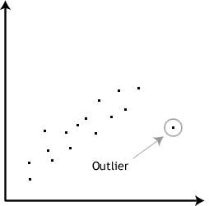

**CONTENTS**

|  |  |  |
| --- | --- | --- |
| **No.** | **Topics** | **Page** |
| 1. | Introduction | 5 |
| 2. | Software Requirements and Specification | 6 |
| 3. | Project Plan | 7 |
| 4. | Future Work | 25 |
| 5. | Conclusion | 26 |
| 6. | References | 27 |
|  |  |  |

**INTRODUCTION**

Credit card fraud is a wide-ranging term for [theft](https://en.wikipedia.org/wiki/Theft) and [fraud](https://en.wikipedia.org/wiki/Fraud) committed using or involving a [payment card](https://en.wikipedia.org/wiki/Payment_card), such as a [credit card](https://en.wikipedia.org/wiki/Credit_card) or [debit card](https://en.wikipedia.org/wiki/Debit_card), as a fraudulent source of funds in a transaction. The purpose may be to obtain goods without paying, or to obtain unauthorized funds from an account. Credit card fraud is also an adjunct to [identity theft](https://en.wikipedia.org/wiki/Identity_theft). According to the [United States](https://en.wikipedia.org/wiki/United_States) [Federal Trade Commission](https://en.wikipedia.org/wiki/Federal_Trade_Commission), while the rate of identity theft had been holding steady during the mid-2000s, it increased by 21 percent in 2008. However, credit card fraud, that crime which most people associate with ID theft, decreased as a percentage of all ID theft complaints for the sixth year in a row.

It is important that credit card companies are able to recognize fraudulent credit card transactions so that customers are not charged for items that they did not purchase.

Although incidences of credit card fraud are limited to about 0.1% of all card transactions, they have resulted in huge financial losses as the fraudulent transactions have been large value transactions. In 1999, out of 12 billion transactions made annually, approximately 10 million—or one out of every 1200 transactions—turned out to be fraudulent. Also, 0.04% (4 out of every 10,000) of all monthly active accounts were fraudulent. Even with tremendous volume and value increase in credit card transactions since then, these proportions have stayed the same or have decreased due to sophisticated [fraud detection](https://en.wikipedia.org/wiki/Fraud_detection) and prevention systems. Today's fraud detection systems are designed to prevent one-twelfth of one percent of all transactions processed which still translates into billions of dollars in losses.

In the decade to 2008, general credit card losses have been 7 [basis points](https://en.wikipedia.org/wiki/Basis_point) or lower (i.e. losses of $0.07 or less per $100 of transactions). In 2007, fraud in the United Kingdom was estimated at £535 million.

So, we will build an algorithm to detect the anomalies or outliers which can help us to identify the frauds. Several algorithms have been trained to detect the frauds and our goal is to compare them and choose the best for the purpose. All this algorithm varies on accuracy and time taken for training which are the main factor for comparison.

We will train the model with various transaction of about 1.5 lakhs customers and total amount credited.

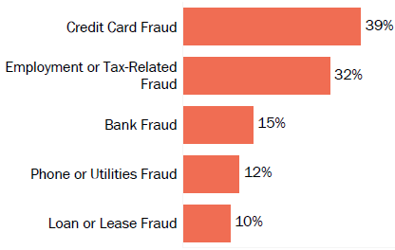

**SOFTWARE REQUIREMENTS**

**AND SPECIFICATION**

**PRODUCT PERSPECTIVE**

The purpose of this project work is to provide a proper supervised and unsupervised methodology and efficient algorithm for the purpose of same. In todays time different type of frauds are increasing rapidly and it is very important to us to understand and implement in correct fashion the proper method of detecting these frauds. A need for increase in low cost and low overhead system is very much in demand for reduction of net customer costs and survival in market survival compilations. So, we aim at developing an algorithm which will prove to be more and more fruitful for this purpose and will be of immense applicability in detecting credit card frauds. The employment of newer concepts and algorithms will prove to be a much better headway in field.

**USER CHARACTERSTICS**

The users who are developing the whole application or are trying to make an evaluation of proper working of newest ideas and the algorithms implemented need to be proficient in the following areas:

* Python programming with libraries Pandas and NumPy
* Visualization libraries like matplotlib and seaborn
* Machine Learning with libraries sklearn, Isolation Forest, One Class SVM, Local Outlier Factor
* Deep Learning with libraries with Keras, Minisom

**SPECIFIC REQUIREMENTS**

The whole project will be developed using the Jupyter Notebook which uses the Python language for the purpose of development of project. So, the specific requirement for this project work are:

* Anaconda including Jupyter Notebook
* Python3
* Windows 7/8/8.1/10 or any compatible operating system

**PROJECT PLAN**

The major aspect of this project to develop a best suited algorithm to find the outliers or frauds in case of credit cards. We will implement several machine learning and deep learning algorithms and compare them and choose the best algorithm.

We will implement algorithms like:

* Neural Network
* Isolation Forest
* OneClassSVM
* Self-Organizing Maps
* Local Outlier Factor
* DBSCAN

For this purpose, we have been provided a dataset. The datasets contain transactions made by credit cards in September 2013 by European cardholders. This dataset presents transactions that occurred in two days, where we have 492 frauds out of 284,807 transactions. The dataset is highly unbalanced, the positive class (frauds) account for 0.172% of all transactions.

It contains only numerical input variables which are the result of a PCA transformation. Unfortunately, due to confidentiality issues, we cannot provide the original features and more background information about the data. Features V1, V2, ... V28 are the principal components obtained with PCA, the only features which have not been transformed with PCA are 'Time' and 'Amount'. Feature 'Time' contains the seconds elapsed between each transaction and the first transaction in the dataset. The feature 'Amount' is the transaction Amount, this feature can be used for example-dependent cost-sensitive learning. Feature 'Class' is the response variable and it takes value 1 in case of fraud and 0 otherwise.

For Dataset [click here](https://drive.google.com/file/d/1dq3k5Lyc_KaVRXVxWX9cmkUhBAZNlCiP/view?usp=sharing)

Now we will study each algorithm in detail.

**1. ARTIFICIAL NEURAL NETWORK (3 LAYER)**

ANN are concept of deep learning which are implement using keras (in this case). ANN are composed of neurons. First layer or Input layer is the input neuron which consist the transaction and amount of each customer. The hidden layer consists of weights, bias and activation function. We can add as much hidden layer for tuning the performance. In this case we are using 3 layers. The output layer is the final layer where we get the classified output. The output either be 1 or 0 where 1 indicate fraud case and 0 indicate normal.

Libraries Used for Data Preprocessing: Pandas, NumPy

Libraries Used for Visualization: Matplotlib, Seaborn

Libraries Used for Neural Network: Keras

Libraries Used for Model Evaluation: Confusion Matrix, Classification Report

Activation Function used in hidden layers: Rectifier

Activation Function used in output layer: Sigmoid

* 1. **Plots**

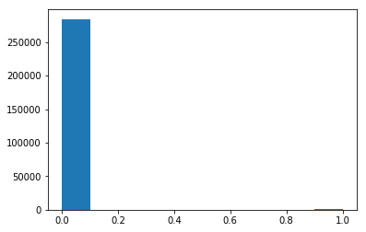

**X=Classes Y=No. of Classes**

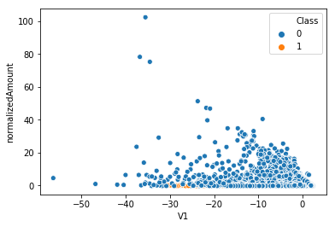

**X=Transaction (can be any case) Y=Amount**

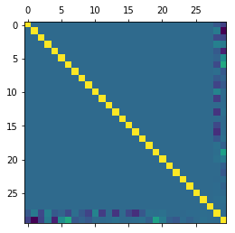

**Correlation Matrix**

* 1. **Code Analysis**

No. of lines of code: **80**

Source Code Memory: **108 kb**

Time taken: **6:16:46 (6 minute 16 seconds 46 nanoseconds) (May vary in different system)**

Model Summary:

_________________________________________________________________

**Layer (type) Output Shape Param #**

**=================================================================**

**dense_1 (Dense) (None, 16) 480**

**_________________________________________________________________**

**dense_2 (Dense) (None, 24) 408**

**_________________________________________________________________**

**dropout_1 (Dropout) (None, 24) 0**

**_________________________________________________________________**

**dense_3 (Dense) (None, 20) 500**

**_________________________________________________________________**

**dense_4 (Dense) (None, 24) 504**

**_________________________________________________________________**

**dense_5 (Dense) (None, 1) 25**

**=================================================================**

**Total params: 1,917**

**Trainable params: 1,917**

**Non-trainable params: 0**

Model Compilation:

**Epoch 1/5**

**199364/199364 [==============================] - 51s 258us/step - loss: 0.0106 - acc: 0.9980**

**Epoch 2/5**

**199364/199364 [==============================] - 48s 243us/step - loss: 0.0040 - acc: 0.9993**

**Epoch 3/5**

**199364/199364 [==============================] - 58s 289us/step - loss: 0.0038 - acc: 0.9993**

**Epoch 4/5**

**199364/199364 [==============================] - 54s 273us/step - loss: 0.0034 - acc: 0.9994**

**Epoch 5/5**

**199364/199364 [==============================] - 46s 233us/step - loss: 0.0032 - acc: 0.9994**

* 1. **Model Evaluation**

Libraries Used: **Confusion Matrix and Classification Report**

Confusion Matrix Results:

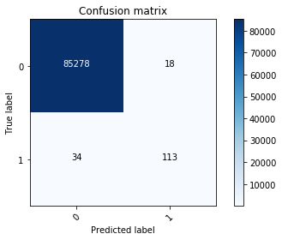

**True Positive=85278**

**True Negative=113**

**False Positive=18**

**False Negative=34**

Classification Report:

**precision recall f1-score support**

**0.0 1.00 1.00 1.00 85312**

**1.0 0.77 0.86 0.81 131**

**micro avg 1.00 1.00 1.00 85443**

**macro avg 0.88 0.93 0.91 85443**

**weighted avg 1.00 1.00 1.00 85443**

Final accuracy achieved: **99% (0.9994)**

* 1. **Source Code**

For ipynb file, [click here](https://drive.google.com/file/d/1L_kJ-0Vd-75i2p24z-wAesYbz7xwCANA/view?usp=sharing)

Place it in your home directory of anaconda and run the file using Jupyter Notebook

**2. Anomaly Detection Algorithms**

**2.1 Isolation Forest**

Isolation forest detects anomalies by randomly partitioning the domain space. Yeah, you’re heard me right- It works similar to [Decision trees](https://scikit-learn.org/stable/modules/tree.html) algorithm, where we start with a root node and keep on partitioning the space. In Isolation forest we partition randomly, unlike Decision trees where the partition is based on gain. Partitions are created by randomly selecting a feature and then randomly creating a split value between the maximum and the minimum value of the feature. We keep on creating the partitions until we isolate all the points (in most cases we also set a limit on number of partitions/heights of the tree).

Libraries Used for Data Preprocessing: **Pandas, NumPy**

Libraries Used for Visualization: **Matplotlib, Seaborn**

Libraries Used for Implementing Algorithm: **sklearn.ensemble**

Hyperparameters Used And their Values**: behaviour='old', bootstrap=False, contamination='legacy',**

**max_features=1.0, max_samples=100, n_estimators=100, n_jobs=None,**

**random_state=None, verbose=0**

**2.1.1 Plots**

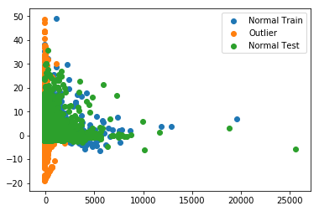

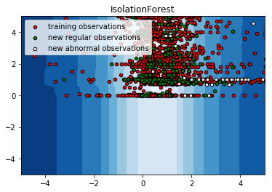

**2.1.2 Code Analysis**

No. of lines of code: **55**

Source Code Memory: **70 kb**

Time taken: **1:10:06 (1 minute 10 seconds 6 nanoseconds) (May vary in different system)**

**2.1.3 Model Accuracy**

Accuracy test: **0.8554597215175602 (85%)**

Accuracy outliners: **0.9044715447154471 (90%)**

* + 1. **Source Code**

For ipynb file, [click here](https://drive.google.com/file/d/1c-rMPVwvgH_luM8Cuh_QSiwKo3m_8E0e/view?usp=sharing)

Place it in your home directory of anaconda and run the file using Jupyter Notebook

**2.2. Local Outlier Factor**

The Local Outlier Factor (LOF) algorithm is an unsupervised anomaly detection method which computes the local density deviation of a given data point with respect to its neighbors. It considers as outliers the samples that have a substantially lower density than their neighbors. This example shows how to use LOF for outlier detection which is the default use case of this estimator in scikit-learn. Note that when LOF is used for outlier detection it has no predict, decision function and score samples methods. The number of neighbors considered (parameter n_neighbors) is typically set 1) greater than the minimum number of samples a cluster has to contain, so that other samples can be local outliers relative to this cluster, and 2) smaller than the maximum number of close by samples that can potentially be local outliers. In practice, such information are generally not available, and taking n_neighbors=20 appears to work well in general.

Libraries Used for Data Preprocessing: **Pandas, NumPy**

Libraries Used for Visualization: **Matplotlib, Seaborn**

Libraries Used for Implementing Algorithm: **sklearn.neighbors**

Hyperparameters Used And their Values**: algorithm='auto', contamination='legacy', leaf_size=30,**

**metric='minkowski', metric_params=None, n_jobs=None,**

**n_neighbors=20, novelty=False, p=2**

**2.2.1 Plots**

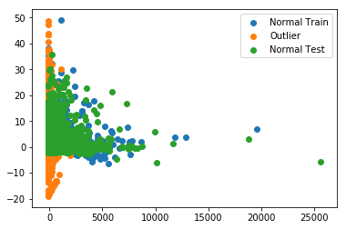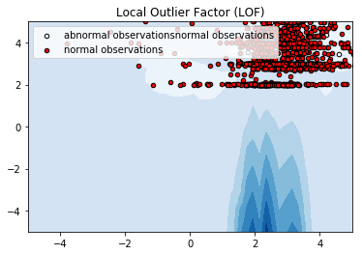

**2.2.2 Code Analysis**

No. of lines of code: **50**

Source Code Memory: **70 kb**

Time taken: **35:10:06 (35 minute 10 seconds 6 nanoseconds) (May vary in different system)**

**2.2.3 Model Accuracy**

Number of error cases:**56695**

Accuracy: **0.8998545127406777(90% approx)**

* + 1. **Source Code**

For ipynb file, [click here](https://drive.google.com/file/d/1c-rMPVwvgH_luM8Cuh_QSiwKo3m_8E0e/view?usp=sharing)

Place it in your home directory of anaconda and run the file using Jupyter Notebook

**2.3. One Class SVM**

A One-Class Support Vector Machine is an unsupervised learning algorithm that is trained only on the ‘normal’ data, in our case the negative examples. It considers as outliers the samples that have a substantially lower density than their neighbors. In one-class learning we train the model only on the positive class data-set and take judgments from it on the universe [A union ~A] spontaneously. It’s a hot research topic and there are multiple tools available, like [One-class SVM](http://scikit-learn.org/stable/modules/generated/sklearn.svm.OneClassSVM.html) and [Isolation Forest](http://scikit-learn.org/stable/modules/generated/sklearn.ensemble.IsolationForest.html), to achieve this task. One-class learning can prove to be vital in scenarios where data consisting of ~A samples can take up any distribution and it isn’t possible to learn a pattern for ~A class.

Libraries Used for Data Preprocessing: **Pandas, NumPy**

Libraries Used for Visualization: **Matplotlib, Seaborn**

Libraries Used for Implementing Algorithm: **sklearn.SVC**

**2.3.1 Plots**



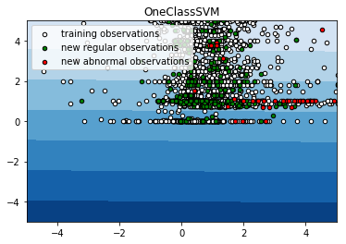

**2.3.2 Code Analysis**

No. of lines of code: **55**

Source Code Memory: **70 kb**

Time taken: **30:15:26 (30 minute 15 seconds 26 nanoseconds) (May vary in different system)**

**2.3.3 Model Accuracy**

Accuracy test: **0.04693753875641243**

Accuracy outliners: **0.9126016260162602**

* + 1. **Source Code**

For ipynb file, [click here](https://drive.google.com/file/d/1c-rMPVwvgH_luM8Cuh_QSiwKo3m_8E0e/view?usp=sharing)

Place it in your home directory of anaconda and run the file using Jupyter Notebook

**3. DBSCAN**

Density-Based Spatial Clustering of Applications with Noise. Another way to find the outliers is DBSCAN which uses clustering. In this method, we calculate the distance between points (the Euclidean distance or some other distance) and look for points which are far away from others. A natural way to group together hosts that are behaving similarly is to use a clustering algorithm. We use DBSCAN, a popular density-based clustering algorithm, for this purpose. DBSCAN works by greedily agglomerating points that are close to each other. Clusters with few points in them are considered outliers. We use a simplified form of DBSCAN to detect outliers on time series. We consider each host to be a point in d-dimensions, where d is the number of elements in the time series. Any point can agglomerate, and any point that is not in the largest cluster will be considered an outlier.

Libraries Used for Data Preprocessing: **Pandas, NumPy**

Libraries Used for Visualization: **Matplotlib, Seaborn**

Libraries Used for Implementing Algorithm: **DBSCAN**

Hyper Parameters: **algorithm='auto', eps=0.5, leaf_size=30, metric='euclidean',**

**metric_params=None, min_samples=10, n_jobs=None, p=None**

**3.1 Plots**



**X=Classes Y=No. of Classes**



**X=Transaction (can be any case) Y=Amount**



**Correlation Matrix**

**3.2 Code Analysis**

No. of lines of code: **60**

Source Code Memory: 2**8 kb**

Time taken: **1:16:46 (6 minute 16 seconds 46 nanoseconds) (May vary in different system)**

* 1. **Model Evaluation**

Libraries Used: **Confusion Matrix and Classification Report**

Confusion Matrix Results:

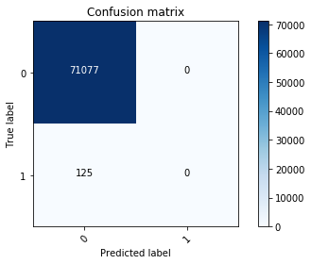

**True Positive=71077**

**True Negative=0**

**False Positive=125**

**False Negative=0**

Classification Report:

**precision recall f1-score support**

**0 1.00 1.00 1.00 71077**

**1 0.00 0.00 0.00 125**

**micro avg 1.00 1.00 1.00 71202**

**macro avg 0.50 0.50 0.50 71202**

**weighted avg 1.00 1.00 1.00 71202**

**Final accuracy achieved:99%**

* 1. **Source Code**

For ipynb file, [click here](https://drive.google.com/open?id=1_IN35KAHLdvUMnonTd2VKmHTsYIOpVvh)

Place it in your home directory of anaconda and run the file using Jupyter Notebook

**4. Self-Organizing Maps**

A **self-organizing map** (**SOM**) is a type of [artificial neural network](https://en.wikipedia.org/wiki/Artificial_neural_network) (ANN) that is trained using unsupervised learning to produce a low-dimensional (typically two-dimensional), discretized representation of the input space of the training samples, called a **map**, and is therefore a method to do dimensionality reduction. Self-organizing maps differ from other artificial neural networks as they apply competitive learning as opposed to error-correction learning (such as backpropagation with gradient descent), and in the sense that they use a neighborhood function to preserve the topological properties of the input space. Each data point in the data set recognizes themselves by competing for representation. SOM mapping steps starts from initializing the weight vectors. From there a sample vector is selected randomly and the map of weight vectors is searched to find which weight best represents that sample. Each weight vector has neighboring weights that are close to it. The weight that is chosen is rewarded by being able to become more like that randomly selected sample vector. The neighbors of that weight are also rewarded by being able to become more like the chosen sample vector. This allows the map to grow and form different shapes. Most generally, they form square/rectangular/hexagonal/L shapes in 2D feature space.

Libraries Used for Data Preprocessing: **Pandas, NumPy**

Libraries Used for Visualization: **Matplotlib, Seaborn**

Libraries Used for Implementing Algorithm: **MINISOM**

**4.1 Plots**

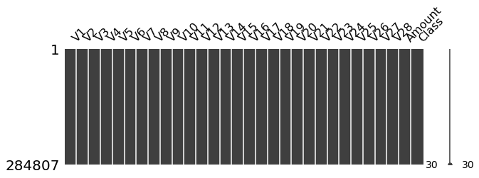

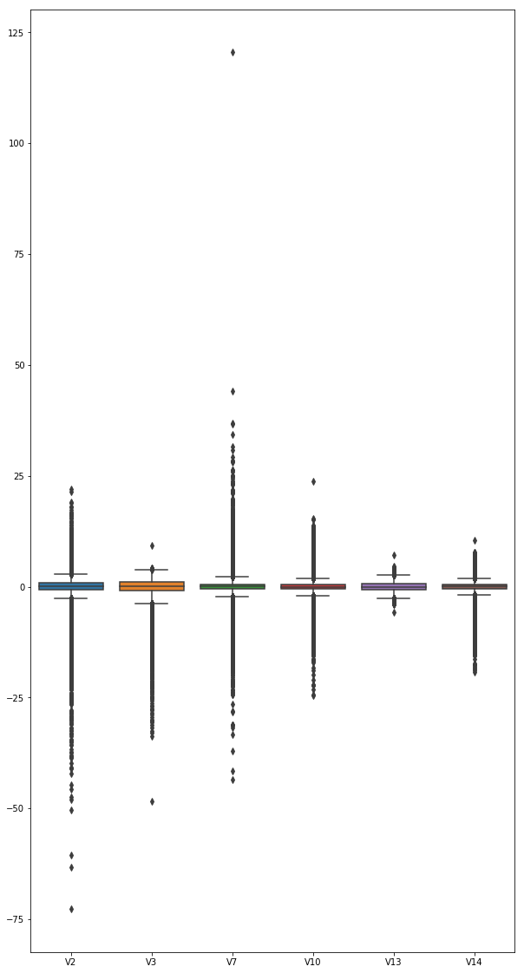

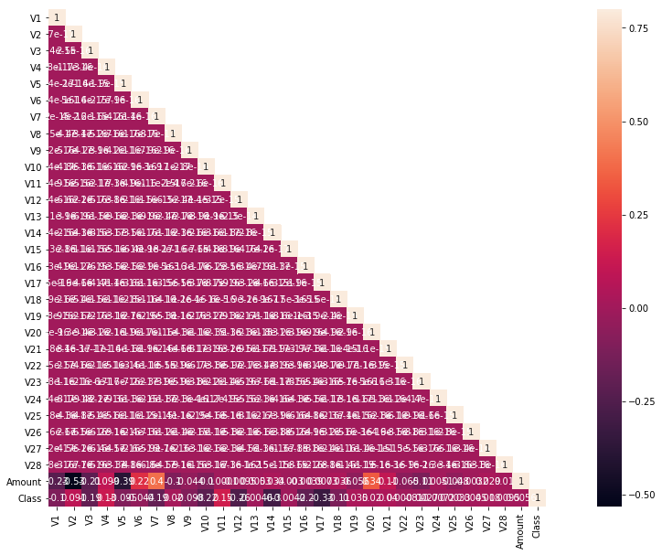

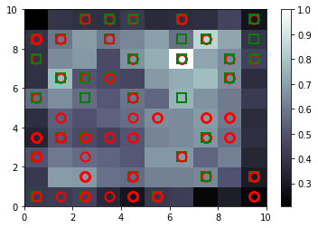

**4.3 Code Analysis**

No. of lines of code: **60**

Source Code Memory: 2**8 kb**

Time taken: **41:20:40 (41 minute 20 seconds 4 nanoseconds) (May vary in different system)**

**4.4 Source Code**

For ipynb file, [click here](https://drive.google.com/open?id=1sqTMxa_o79RJQuKvoBWBVBo5HU7gktD7)

Place it in your home directory of anaconda and run the file using Jupyter Notebook

**FUTURE WORK**

Many different adaptations, tests, and experiments have been left for the future due to lack of time (i.e. the experiments with real data are usually very time consuming, requiring even days to finish a single run). Future work concerns deeper analysis of particular mechanisms, new proposals to try different methods, or simply curiosity. Obviously, the use of other types of individual representations and suitable algorithms could be implemented since they have an important influence on the results obtained at the end.

**CONCLUSION**

Several algorithms have been implemented on same data set to detect the frauds in case of credit cards. All the algorithms have been analyzed and compared on basis of accuracy they are giving on same data. We implemented different type of algorithms which include neural network from deep learning, anomaly detection algorithms like isolation forest, OneClassSVM, Local Outlier Factor, supervised algorithm like DBSCAN and unsupervised algorithm like Self-Organizing Maps. This was done to attain the best approach for the purpose.

Upon analyzing we conclude that 3-Layer Neural Network have been the best algorithms for the purpose of credit card fraud detection as it provides best accuracy with best precision and recall on both cases. It was also decent in case of time complexity and space complexity but not the best compared to isolation forest and DBSCAN. But accuracy is best of all. It gives 99% accuracy which close to perfect. DBSCAN algorithm is also providing the 99% accuracy but its precision and recall are zero for fraud case which is not acceptable.

In future this type of algorithm can be used in different cases. For better performance we can change the layers properties for better results. This also proves the importance of deep learning in field of artificial intelligence.

**REFERENCES**

<http://mlg.ulb.ac.be>

<https://www.researchgate.net/project/Fraud-detection-5>

<https://www.datadoghq.com/blog/outlier-detection-algorithms-at-datadog/#dbscan>

<https://towardsdatascience.com/self-organizing-maps-ff5853a118d4>

<https://towardsdatascience.com/outlier-detection-with-isolation-forest-3d190448d45e>

<https://towardsdatascience.com/local-outlier-factor-for-anomaly-detection-cc0c770d2ebe>

<https://carldawson.net/outlier-detection-svm/>

<https://www.kaggle.com/mlg-ulb/creditcardfraud>